**Develop an application that uses Layout Managers and event listeners.**

**Aim:**  Develop an application that uses Layout Managers and event listeners.

**Procedure:**

**Creating a New project:**

* Open Android Studio and then click on **File -> New -> New project.**

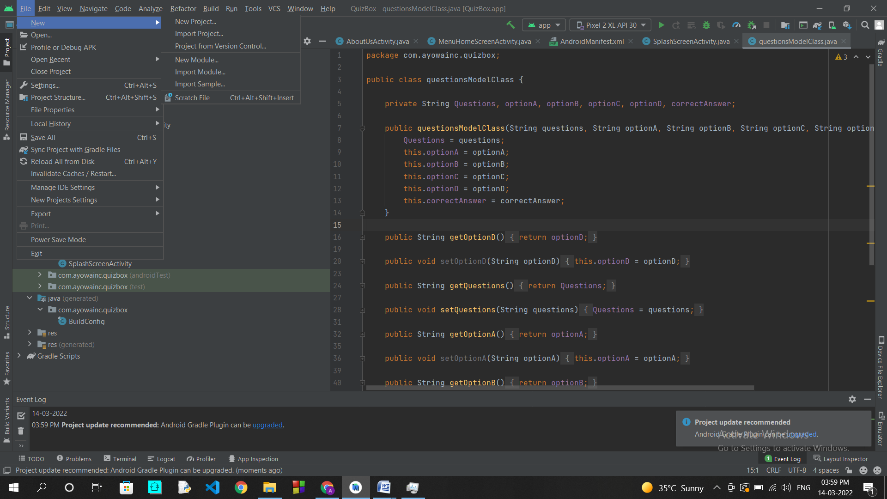

* Then type the Application name as “**exno2″** and click **Next.**

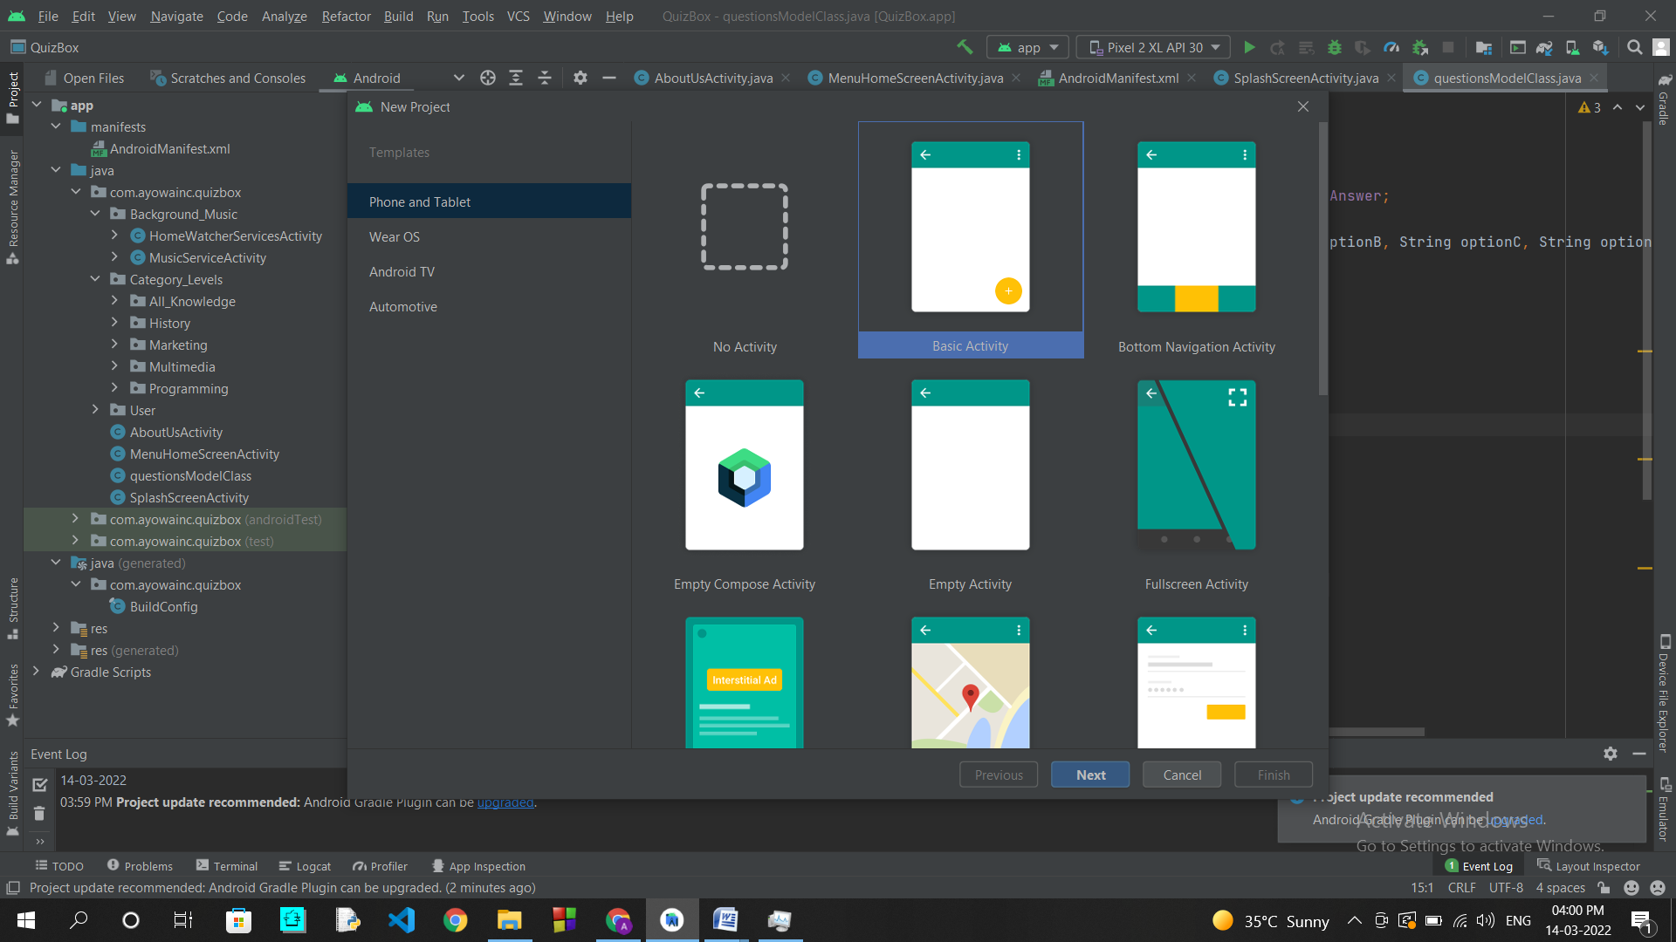

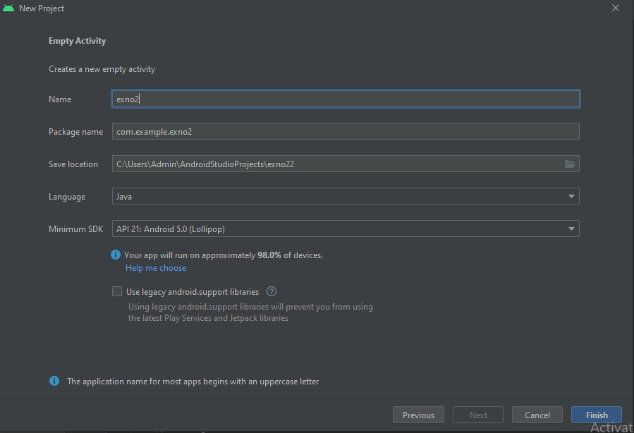

* Then select the **Minimum SDK** as shown below and click **Next**.
* Finally click F**inish**.
* It will take some time to build and load the project.
* After completion it will look as given below.

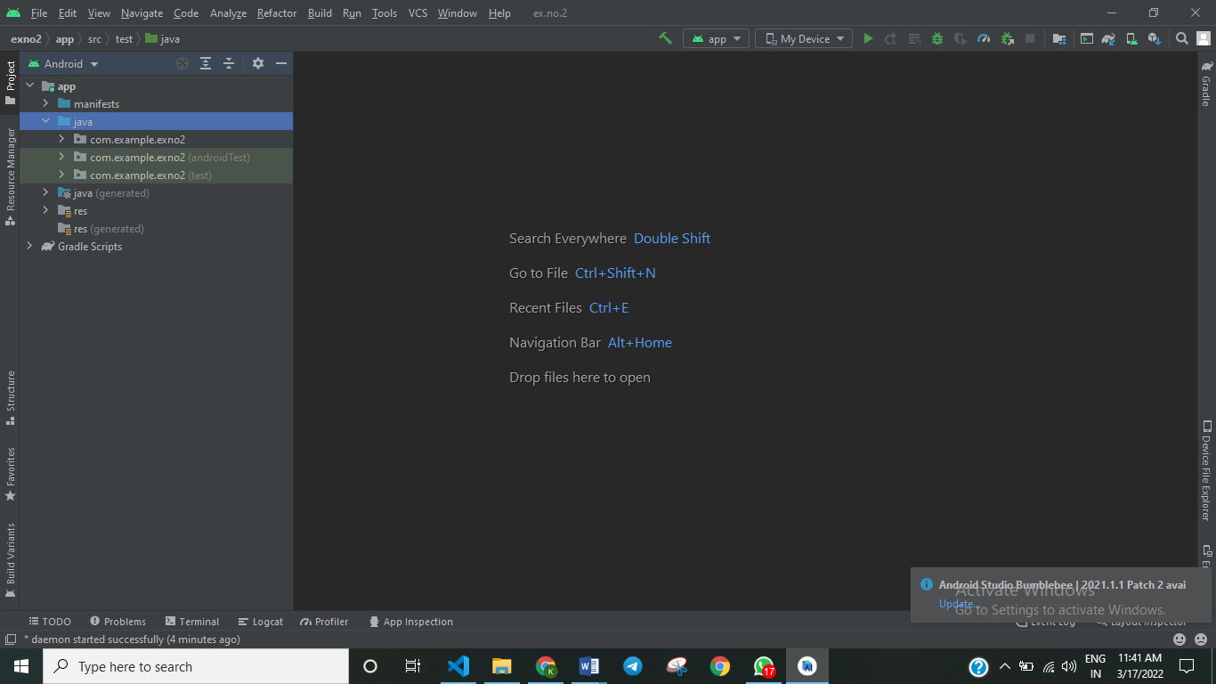

**Designing layout for the Android Application:**

* Click on **app -> res -> layout -> activity_main.xml.**

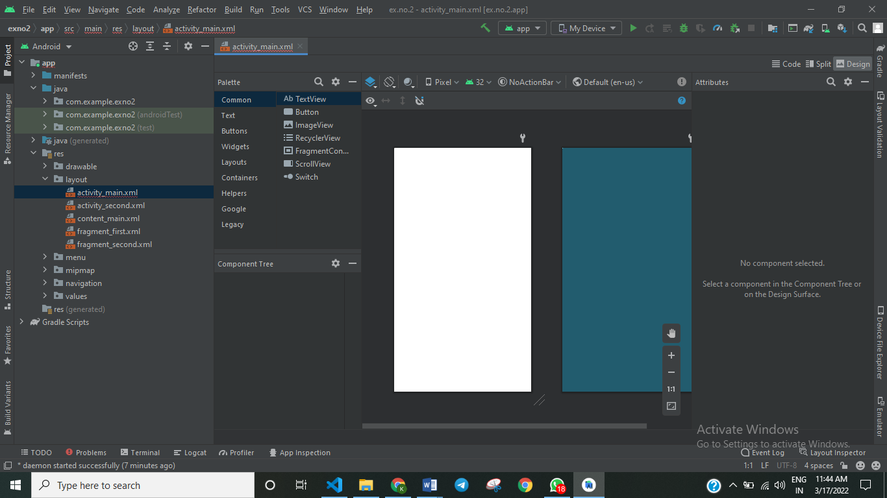

**Code for Activity_main.xml:**

* <?xml version="1.0" encoding="utf-8"?>  
  <androidx.coordinatorlayout.widget.CoordinatorLayout xmlns:android="http://schemas.android.com/apk/res/android"  
   xmlns:app="http://schemas.android.com/apk/res-auto"  
   xmlns:tools="http://schemas.android.com/tools"  
   android:layout_width="match_parent"  
   android:layout_height="match_parent"  
   tools:context=".MainActivity">  
    
   <com.google.android.material.appbar.AppBarLayout  
   android:layout_width="match_parent"  
   android:layout_height="wrap_content"  
   android:theme="@style/Theme.Exp1.AppBarOverlay">  
    
   <androidx.appcompat.widget.Toolbar  
   android:id="@+id/toolbar"  
   android:layout_width="match_parent"  
   android:layout_height="?attr/actionBarSize"  
   android:background="?attr/colorPrimary"  
   app:popupTheme="@style/Theme.Exp1.PopupOverlay" />  
    
   </com.google.android.material.appbar.AppBarLayout>  
    
   <include layout="@layout/content_main" />  
    
   <com.google.android.material.floatingactionbutton.FloatingActionButton  
   android:id="@+id/fab"  
   android:layout_width="wrap_content"  
   android:layout_height="wrap_content"  
   android:layout_gravity="bottom|end"  
   android:layout_marginEnd="@dimen/fab_margin"  
   android:layout_marginBottom="16dp"  
   app:srcCompat="@android:drawable/ic_dialog_email" />  
    
  </androidx.coordinatorlayout.widget.CoordinatorLayout>

**Code for activity_second.xml :**

<?xml version="1.0" encoding="utf-8"?>  
<LinearLayout xmlns:android="http://schemas.android.com/apk/res/android"  
 xmlns:tools="http://schemas.android.com/tools"  
 android:layout_width="match_parent"  
 android:layout_height="match_parent"  
 tools:context="com.example.exno2.SecondActivity"  
 android:orientation="vertical"  
 android:gravity="center">  
  
 <TextView  
 android:id="@+id/textView1"  
 android:layout_width="wrap_content"  
 android:layout_height="wrap_content"  
 android:layout_margin="20dp"  
 android:text="New Text"  
 android:textSize="30sp"/>  
  
 <TextView  
 android:id="@+id/textView2"  
 android:layout_width="wrap_content"  
 android:layout_height="wrap_content"  
 android:layout_margin="20dp"  
 android:text="New Text"  
 android:textSize="30sp"/>  
  
 <TextView  
 android:id="@+id/textView3"  
 android:layout_width="wrap_content"  
 android:layout_height="wrap_content"  
 android:layout_margin="20dp"  
 android:text="New Text"  
 android:textSize="30sp"/>  
  
</LinearLayout>

* Now click on Design and your application will look as given below.

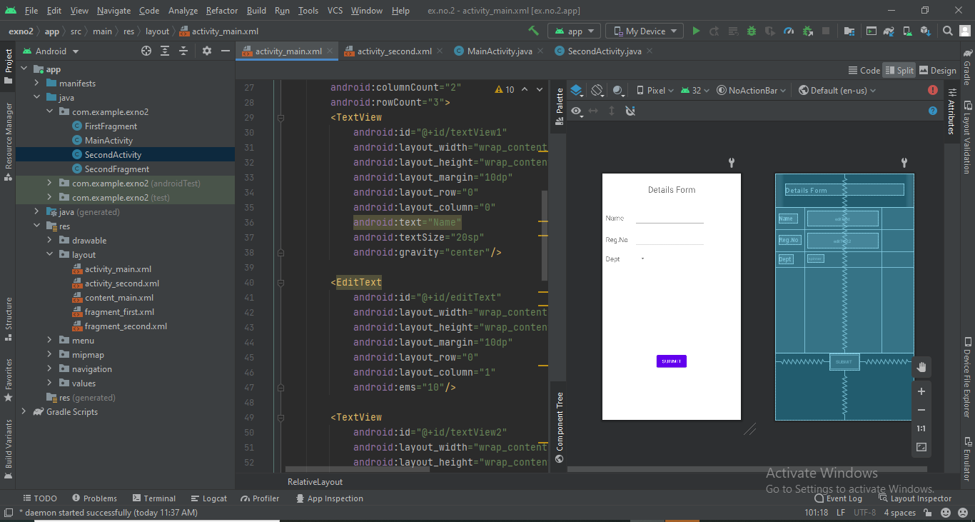

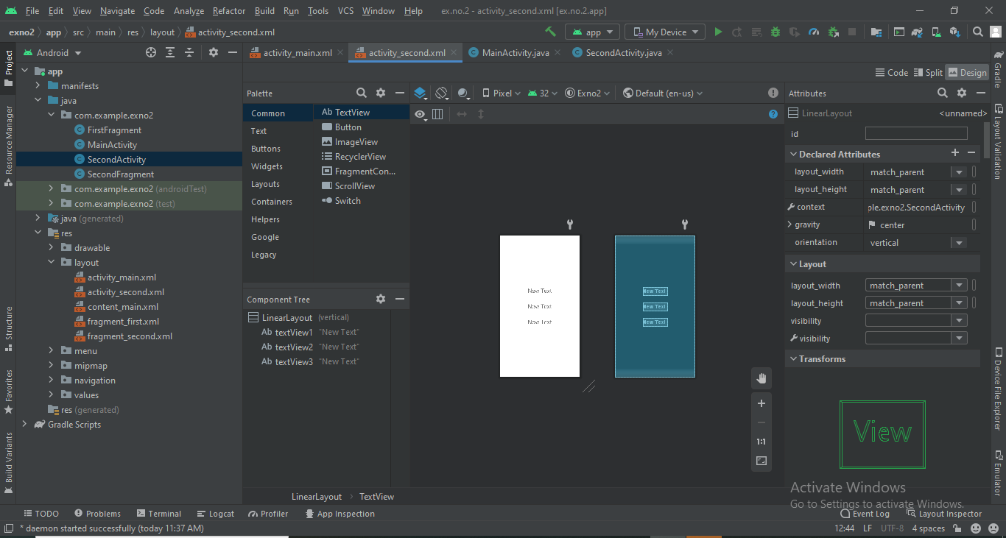

**Java Coding for the Android Application:**

* Click on **app -> java -> com.example.exno2 ->MainActivity.**

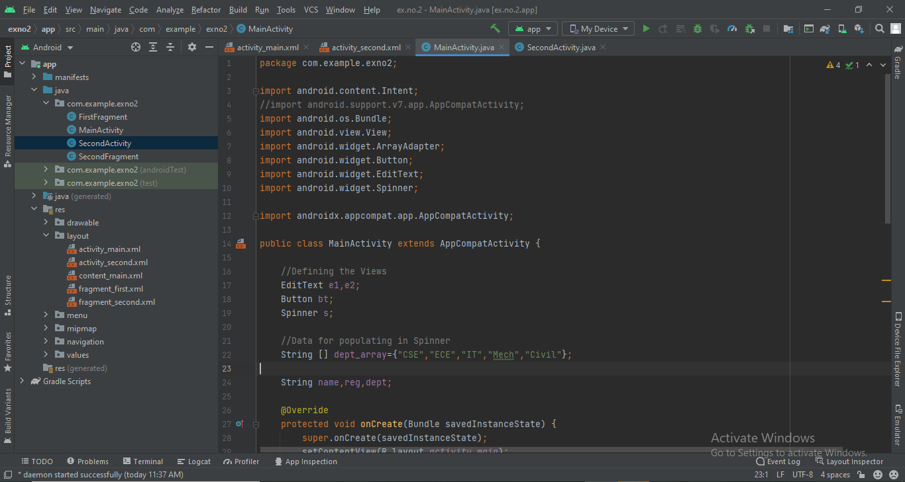

**Code for MainActivity.java:**

package com.example.exno2;  
  
import android.content.Intent;  
//import android.support.v7.app.AppCompatActivity;  
import android.os.Bundle;  
import android.view.View;  
import android.widget.ArrayAdapter;  
import android.widget.Button;  
import android.widget.EditText;  
import android.widget.Spinner;  
  
import androidx.appcompat.app.AppCompatActivity;  
  
public class MainActivity extends AppCompatActivity {  
  
 //Defining the Views  
 EditText e1,e2;  
 Button bt;  
 Spinner s;  
  
 //Data for populating in Spinner  
 String [] dept_array={"CSE","ECE","IT","Mech","Civil"};  
  
 String name,reg,dept;  
  
 @Override  
 protected void onCreate(Bundle savedInstanceState) {  
 super.onCreate(savedInstanceState);  
 setContentView(R.layout.*activity_main*);  
  
 //Referring the Views  
 e1= (EditText) findViewById(R.id.*editText*);  
 e2= (EditText) findViewById(R.id.*editText2*);  
  
 bt= (Button) findViewById(R.id.*button*);  
  
 s= (Spinner) findViewById(R.id.*spinner*);  
  
 //Creating Adapter for Spinner for adapting the data from array to Spinner  
 ArrayAdapter adapter= new ArrayAdapter(MainActivity.this,android.R.layout.*simple_spinner_item*,dept_array);  
 s.setAdapter(adapter);  
  
 //Creating Listener for Button  
 bt.setOnClickListener(new View.OnClickListener() {  
 @Override  
 public void onClick(View v) {  
  
 //Getting the Values from Views(Edittext & Spinner)  
 name=e1.getText().toString();  
 reg=e2.getText().toString();  
 dept=s.getSelectedItem().toString();  
  
 //Intent For Navigating to Second Activity  
 Intent i = new Intent(MainActivity.this,SecondActivity.class);  
  
 //For Passing the Values to Second Activity  
 i.putExtra("name_key", name);  
 i.putExtra("reg_key",reg);  
 i.putExtra("dept_key", dept);  
  
 startActivity(i);  
  
 }  
 });  
 }  
}

**Code for SecondActivity.java**:

package com.example.exno2;  
  
import android.content.Intent;  
//import android.support.v7.app.AppCompatActivity;  
import android.os.Bundle;  
import android.widget.TextView;  
  
import androidx.appcompat.app.AppCompatActivity;  
  
public class SecondActivity extends AppCompatActivity {  
  
 TextView t1,t2,t3;  
  
 String name,reg,dept;  
  
 @Override  
 protected void onCreate(Bundle savedInstanceState) {  
 super.onCreate(savedInstanceState);  
 setContentView(R.layout.*activity_second*);  
  
 t1= (TextView) findViewById(R.id.*textView1*);  
 t2= (TextView) findViewById(R.id.*textView2*);  
 t3= (TextView) findViewById(R.id.*textView3*);  
  
 //Getting the Intent  
 Intent i = getIntent();  
  
 //Getting the Values from First Activity using the Intent received  
 name=i.getStringExtra("name_key");  
 reg=i.getStringExtra("reg_key");  
 dept=i.getStringExtra("dept_key");  
  
 //Setting the Values to Intent  
 t1.setText(name);  
 t2.setText(reg);  
 t3.setText(dept);  
  
 }  
}

**Output:**

**Result:**

              Thus we Developed an application that uses Layout Managers and event listeners.